Private Equity Deal

Private equity is capital that is not noted on a public exchange.Private equity is composed of funds and investors that directly invest in private companies, or that engage in buyouts of public companies, resulting in the delisting of public equity.

Table are used:
- Private_equity_deals

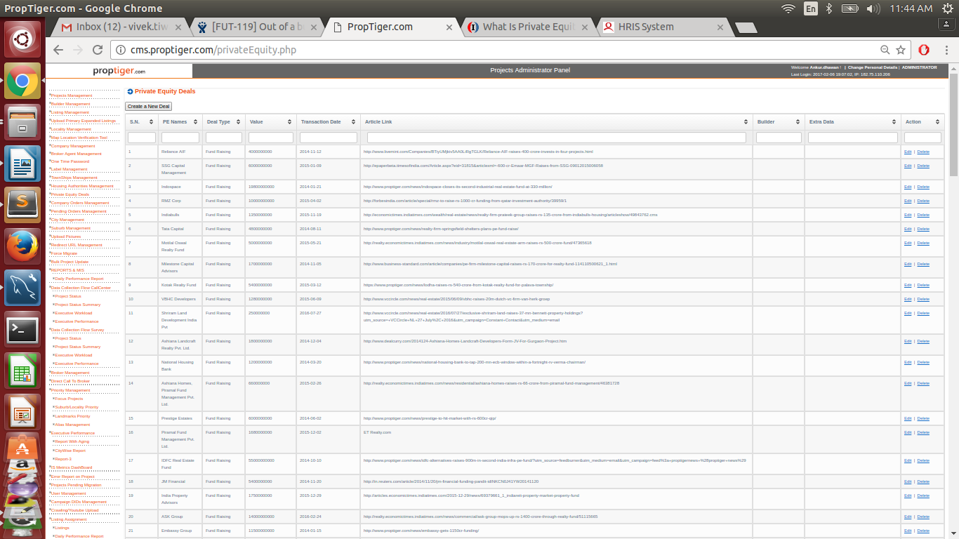

Adding Private Equity Deal

This is categorized under three types :

a. Fund Rasing :
The mandatory field parameters are Private Equity Name and Date of Transaction.
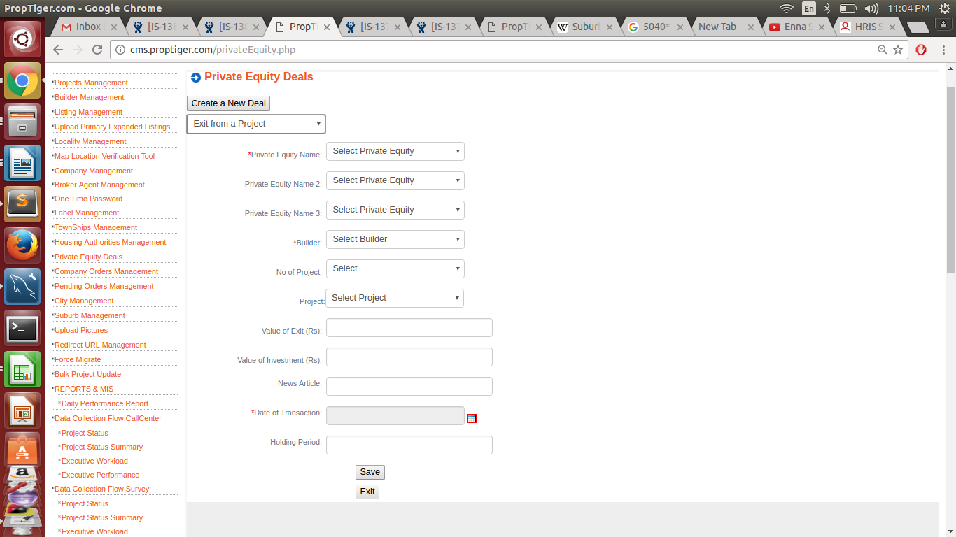

b. Investement in a Project
The mandatory parameters are Private Equity Name, Builder and Date of Transaction.

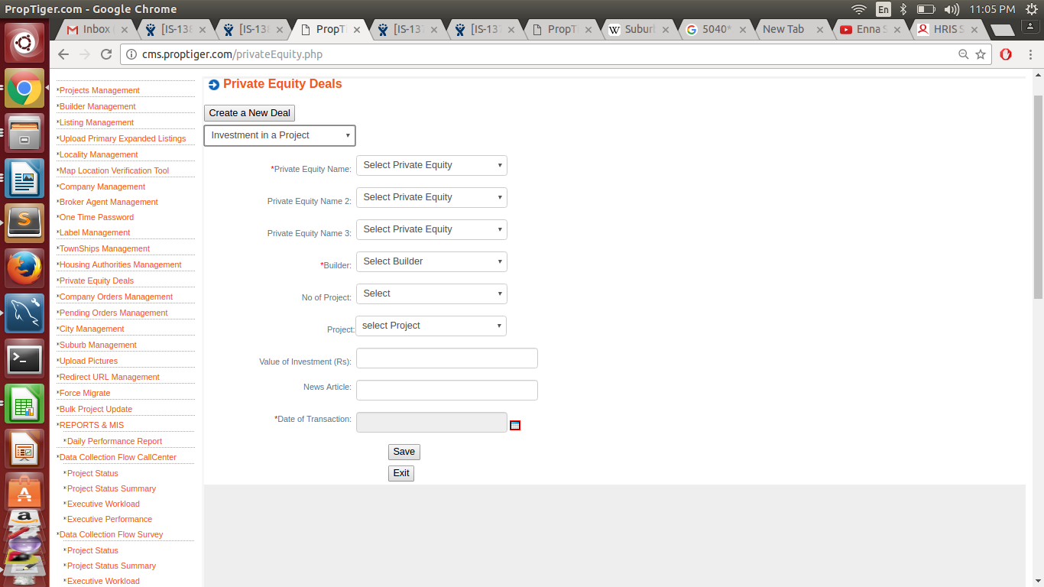

c. Exit from a Project
Like Fund Rasing option the mandatory fields under this option also are Private Equity Name of Date of Transaction.

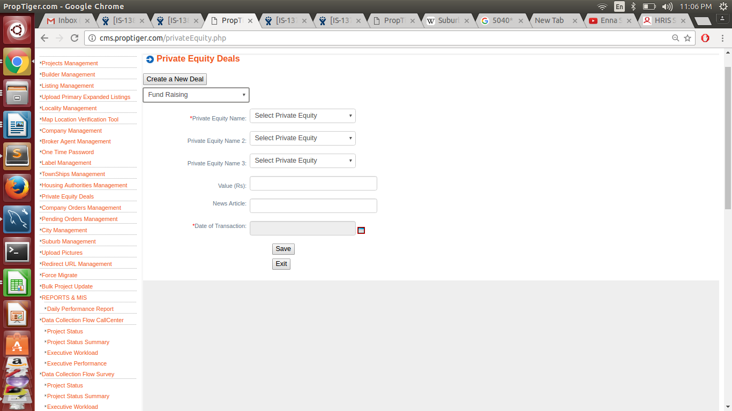
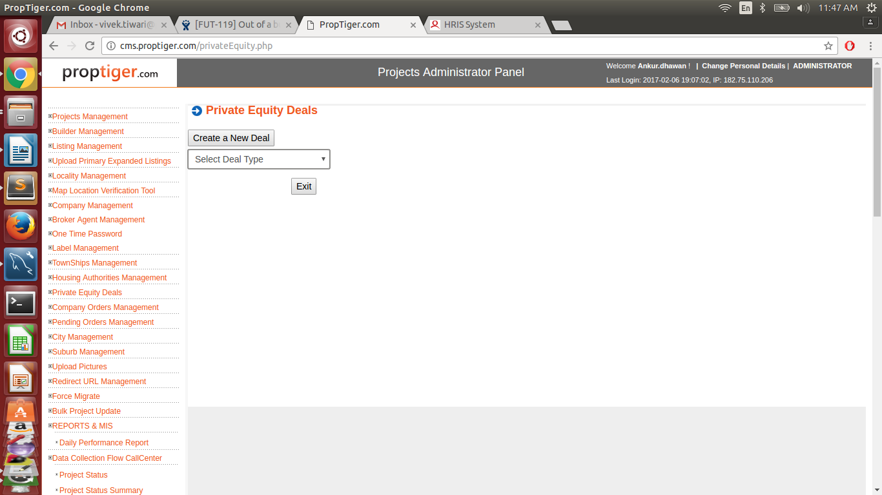

Schema of table:

CREATE TABLE `private_equity_deals` (
`id` int(11) NOT NULL AUTO_INCREMENT,
`type` enum('Fund Raising','Investment','Exit') NOT NULL,
`pe_id` int(11) NOT NULL,
`pe_id_2` int(11) DEFAULT NULL,
`pe_id_3` int(11) DEFAULT NULL,
`builder_id` int(11) DEFAULT NULL,
`value` double DEFAULT NULL,
`article_link` varchar(256) DEFAULT NULL,
`transaction_date` date NOT NULL,
`extra_values` varchar(256) DEFAULT NULL,
PRIMARY KEY (`id`),
KEY `pe_deals_k1` (`pe_id`),
KEY `pe_deals_k2` (`builder_id`),
KEY `private_equity_deals_1` (`pe_id_2`),
KEY `private_equity_deals_2` (`pe_id_3`),
CONSTRAINT `pe_deals_fk1` FOREIGN KEY (`pe_id`) REFERENCES `company` (`id`),
CONSTRAINT `pe_deals_fk2` FOREIGN KEY (`builder_id`) REFERENCES `company` (`id`),
CONSTRAINT `private_equity_deals_ibfk_1` FOREIGN KEY (`pe_id_2`) REFERENCES `company` (`id`) ON DELETE NO ACTION ON UPDATE NO ACTION,
CONSTRAINT `private_equity_deals_ibfk_2` FOREIGN KEY (`pe_id_3`) REFERENCES `company` (`id`) ON DELETE NO ACTION ON UPDATE NO ACTION
) ENGINE=InnoDB AUTO_INCREMENT=319 DEFAULT CHARSET=latin1 COMMENT='master table for storing all Private Equity Deals'

